
NAME: BISMA FATIMA
CLASS: CS A
ROLL NO: F24605036
COURSE: INFORMATION SECURITY
COURSE CODE: CS-291
LECTURER: MISS ATTIA ASHRAF

LAB 10

Understanding Buffer Overflow
Consider the following code, where a buffer overflow vulnerability is present:
#include <stdio.h>
#include <string.h>
void vulnerableFunction(char *input) {
char buffer[10]; // Buffer with a fixed size of 10 bytes
strcpy(buffer, input); // Copying input without bounds checking
printf("You entered: %s\n", buffer);
}
int main() {
char input[100];
printf("Enter some text: ");
gets(input); // Unsafe function that reads input without bounds checking vulnerableFunction(input);
return 0;
}

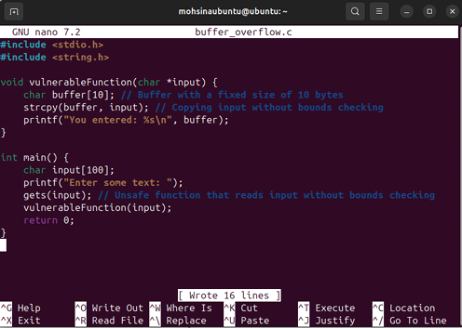
Lab Activities
2.1 Compile and Run the Program
1. Create the C program:
o Open a text editor (e.g., Nano or Vim), copy the above code, and save it as buffer_overflow.c.
2. Compile the Program:
o Open a terminal and run:
gcc -o overflow buffer_overflow.c
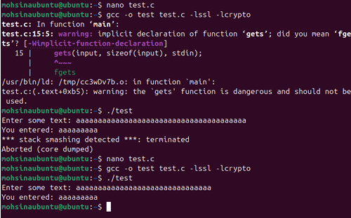
3. Run the Program:
o Execute the program:
./overflow


4. Provide Input:
o Input some text of varying lengths to see how the program behaves.
2.2 Exploiting the Vulnerability
1. Enter a Long Input:
o When prompted to "Enter some text," input a long string, such as:
AAAAAAAAAAAAAAAAAAAAAAAAAAAAAAAAAAAAAAAAAAAAAA
2. Observe the Behavior:
o The program may crash or produce unexpected output, which is an indication of buffer overflow.
2.3 Inspect Memory and Stack
1. Use gdb to Debug:
o To analyze the program's behavior in more detail, use the GNU Debugger (gdb):
gdb ./overflow
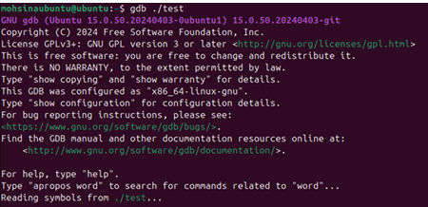
o Run the program in gdb:
run
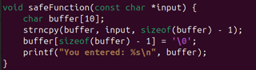
2. Set a Breakpoint:
o Set a breakpoint at the vulnerable function:
break vulnerableFunction
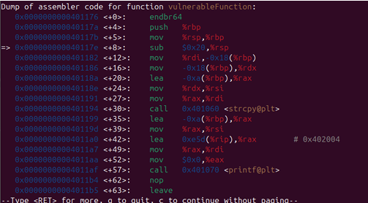
3. Analyze the Stack:
o When the program hits the breakpoint, use the following command to inspect the stack: info frame
2.4 Modify the Input to Cause a Segmentation Fault
1. Run the Program with Exploit Input:
o Input a string of characters long enough to overflow the buffer, such as:
AAAAAAAAAAAAAAAAAAAAAAAAAAAAAAAAAAAA
2. Observe the Result:
o If successful, the program should crash with a segmentation fault due to the buffer overflow.

Part 3: Mitigation and Prevention
3.1 Fix the Vulnerability in the Code
1. Replace Unsafe Functions:
o Replace the unsafe strcpy function with strncpy, which limits the number of characters copied: strncpy(buffer, input, sizeof(buffer) - 1);
buffer[sizeof(buffer) - 1] = '\0'; // Null-terminate the string
2. Avoid Using gets:
o gets is inherently unsafe. Replace it with fgets:
Page 3
fgets(input, sizeof(input), stdin);
3.2 Recompile and Test
1. Recompile the Modified Code:
o After making the changes, recompile the code:
gcc -o overflow_fixed buffer_overflow.c
2. Test with Long Input:
o Run the program again and provide long input. This time, the overflow should not occur, and the program should handle the input gracefully.
Lab Summary
In this lab, you learned about buffer overflow vulnerabilities, identified a vulnerable C program, and performed an exploit by providing carefully crafted input. You also learned how to fix the vulnerability and prevent buffer overflow attacks.
Lab Submission Requirements
1. The modified code that prevents buffer overflow.
2. An analysis of logs of the program crashing due to buffer overflow.
3. An analysis of logs of the program after the vulnerability is fixed.

